**Modul 4**

Nama : Andrias Sigid W.R

NIM : L200144010

Percobaan 1

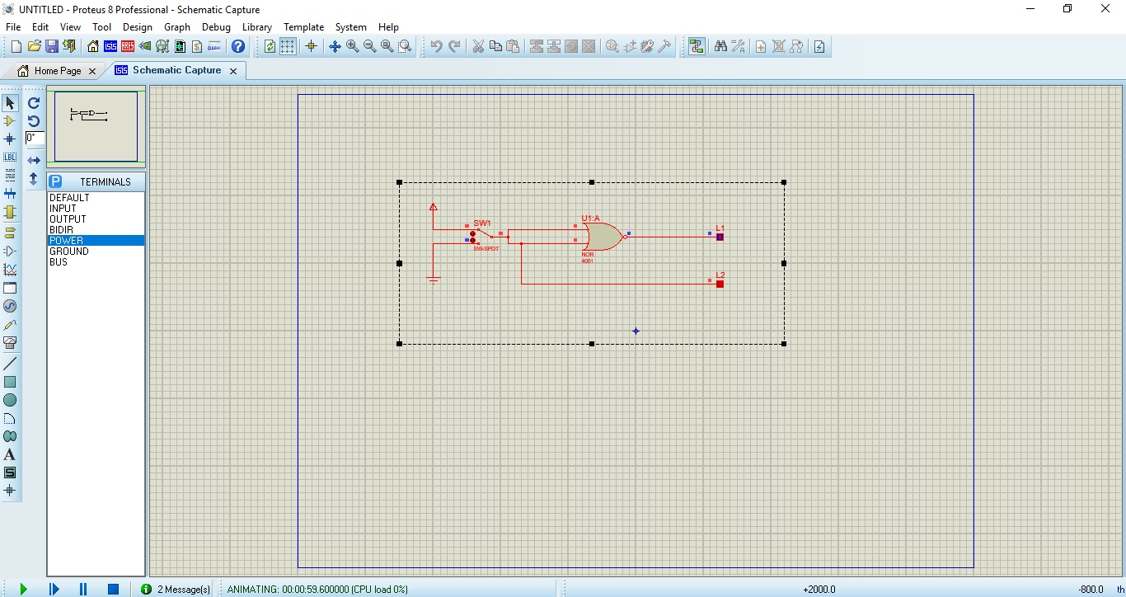

|  |  |  |
| --- | --- | --- |
| SW1 | L2 | L1 |
| 0 | 0 | 1 |
| 1 | 1 | 0 |

Percobaan 2

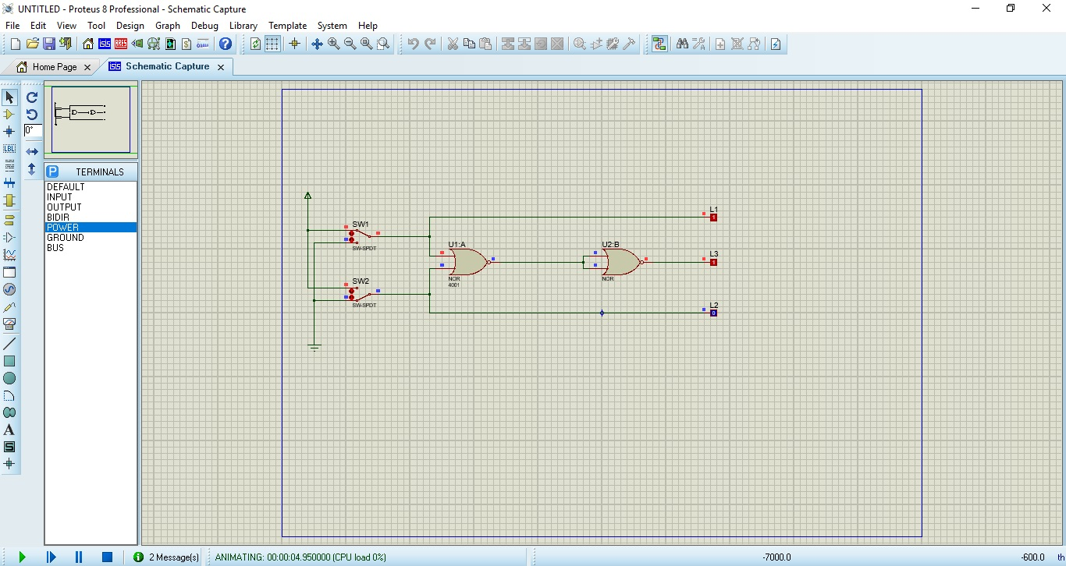

|  |  |  |  |  |
| --- | --- | --- | --- | --- |
| SW1 | SW2 | L1 | L2 | L3 |
| 0 | 0 | 0 | 0 | 0 |
| 1 | 0 | 1 | 0 | 1 |
| 0 | 1 | 0 | 1 | 1 |
| 1 | 1 | 1 | 1 | 1 |

Percobaan 3

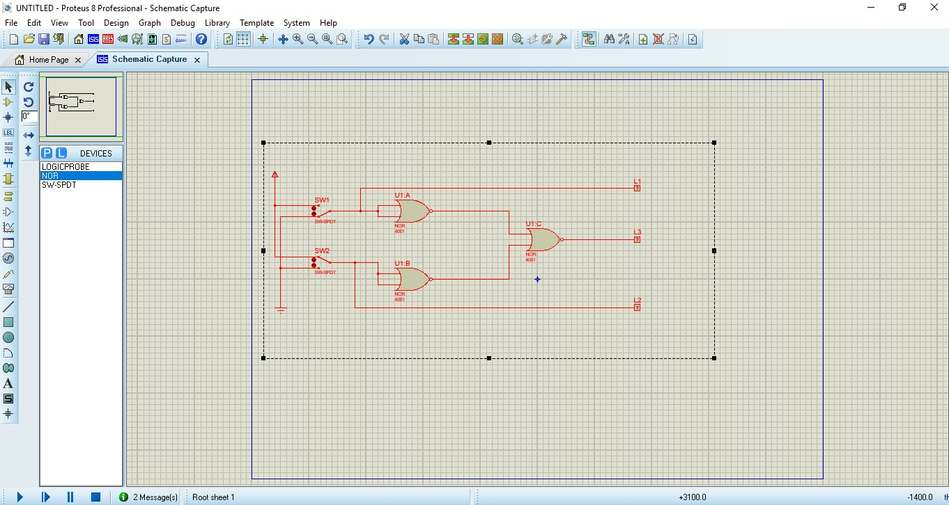

|  |  |  |  |  |
| --- | --- | --- | --- | --- |
| SW1 | SW2 | L1 | L2 | L3 |
| 0 | 0 | 0 | 0 | 0 |
| 1 | 0 | 1 | 0 | 0 |
| 0 | 1 | 0 | 1 | 0 |
| 1 | 1 | 1 | 1 | 1 |

Percobaan 4

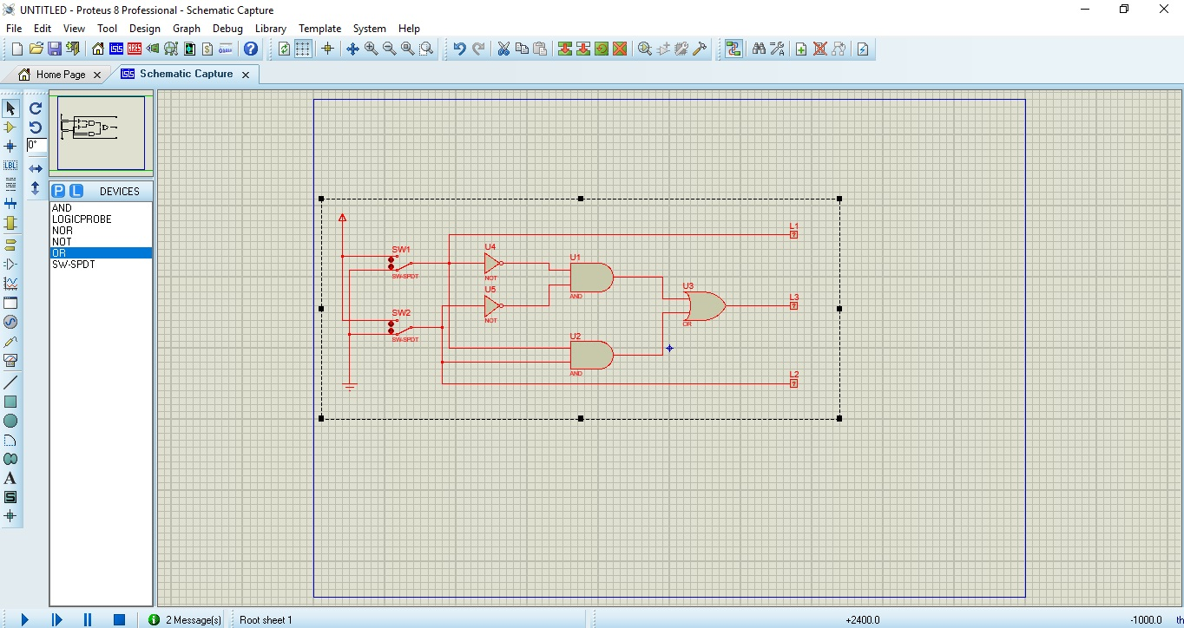

|  |  |  |  |  |
| --- | --- | --- | --- | --- |
| SW1 | SW2 | L1 | L2 | L3 |
| 0 | 0 | 0 | 0 | 1 |
| 1 | 0 | 1 | 0 | 0 |
| 0 | 1 | 0 | 1 | 0 |
| 1 | 1 | 1 | 1 | 1 |

Percobaan 5